Basic HTML 02

|  |  |
| --- | --- |
| Lab Session - 02 | Marks (5) |

Create the HTML page displayed on the following page, use the image placed in this folder.

After you are done, please answer the following questions:

1. What are the security issues of the web?

computer viruses, data theft, and phishing attacks.

1. What can we do to deal with each of this security?

Identify the risks you might face, Plan a strategy to deal with any security issues, and Decide whether it is wise to take legal action in view of the risks.

1. Explain the following:
   1. IP: the Internet Protocol (IP) address of a machine connected to the Internet is a unique
   2. TCP: TCP enables data to be transferred between applications and devices on a network and is used in the TCP IP model.
   3. FTP: File Transfer Protocol" and refers to a group of rules that govern how computers transfer files from one system to another
   4. HTTP: **It is a protocol used by the World Wide Web**
   5. HTML: HyperText Markup Language is the most basic building block of the Web
   6. Domain : text address for web pages.
   7. HyperText: text that can be read in a non-linear way.
   8. Hyper media: Hypertext + media such as sound and images
2. Explain the concept of server client model?

is a distributed application framework dividing tasks between servers and clients, which either reside in the same system or communicate through a computer network or the Internet

1. What do you use the following for:
   1. HTML: create electronic documents
   2. CSS: is used to style and layout web pages
   3. JS: JavaScript is commonly used for creating web pages
   4. PHP: scripting language that can be used to develop dynamic and interactive websites.
   5. XML: uses for Web, e-business, and portable applications.
2. What does the following html do:
   1. <!DOCTYPE html> : Every XHTML document must begin with: DOCTYPE
   2. <h1> Chapter 01 </h1> :Write it in bigger size
   3. <title> Page 01 </title> : element tells the browser that this is the title of the page
   4. <meta chartset=”UTF-8”/> : tells the browser to use the utf-8 character
3. What is the close tag of each of the following elements?

|  |  |
| --- | --- |
| <blockquote> | </blockquote> |
| <img | /> |
| <br> | <br> |

Submit a compressed file which include: the HTML file, the image file and the doc file with your answers

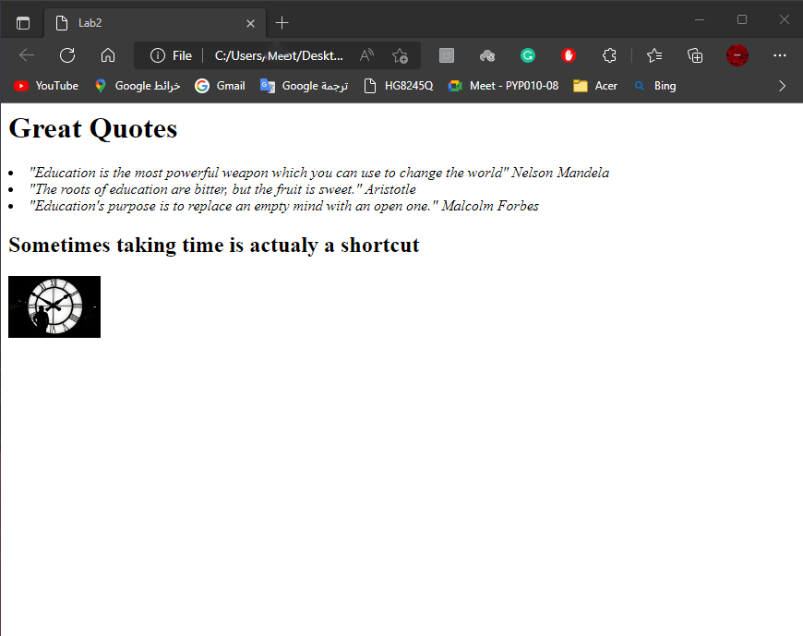

<h1>

<cite>

<h2>

<img>

Height=”100” width=”100”

<ul>

<li>